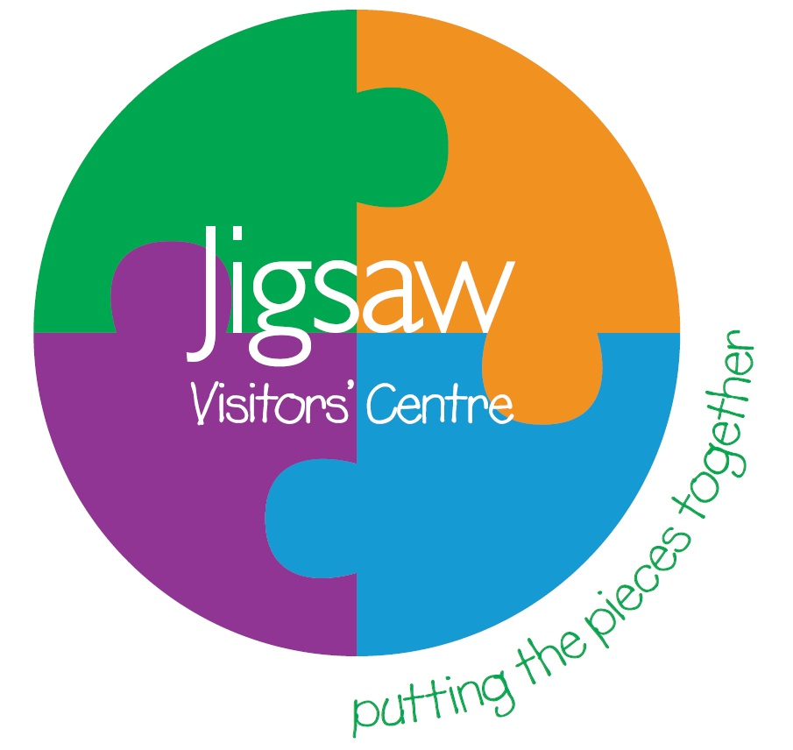 Family Support In to Out Referral Form

Jigsaw offers intensive community support to families of prisoners in the West Yorkshire area. Families will be assessed and either offered intensive support for up to 1 year or light touch support.

Date: ……………………………………………… Prison: HMP Leeds  

Person referring/agency: ……………………………………………Contact no:……………………………
Family member
First name |  | Surname
Phone number
Prisoner
First name |  | Surname
Prison No. |  | Wing & Cell No.
Release date if applicable |  |  |  |  | SO (office use only) | 1 2 3
Length of sentence if applicable
Status | Sentenced  Released    Remand 
Area of residence | Leeds  Bradford Kirklees  Calderdale  Wakefield 
Support Needs  (Please Circle) | Emotional Support Debt, Benefits, Budgeting  Relationships Children’s Education  Employment/Training ,Education Access to Healthcare  Substance Misuse Children’s Well-being
Additional information
(e.g. other agencies involved)
Level of support required | Information only  Short term support Ongoing support 

For office use:
Reference No:
On Data Base: | CNOMIS checked:

